**Name:** M Abhinay Babu

**Reg No:** 22BCE9726

1.Write an SQL query to fetch unique values of DEPARTMENT from Worker table.

**Answer:**

SELECT DISTINCT DEPARTMENT FROM Worker;

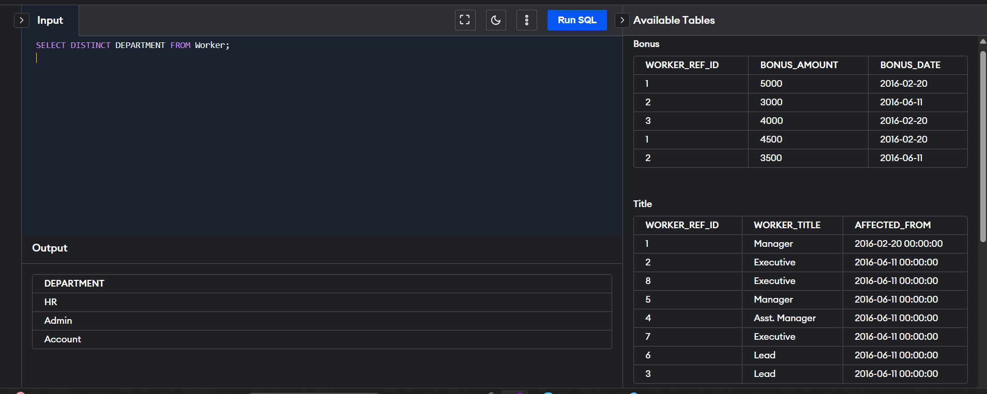

2. Write an SQL query to print all Worker details from the Worker table order by FIRST_NAME Ascending and DEPARTMENT Descending

**Answer:**

SELECT * FROM Worker

ORDER BY FIRST_NAME ASC, DEPARTMENT DESC;

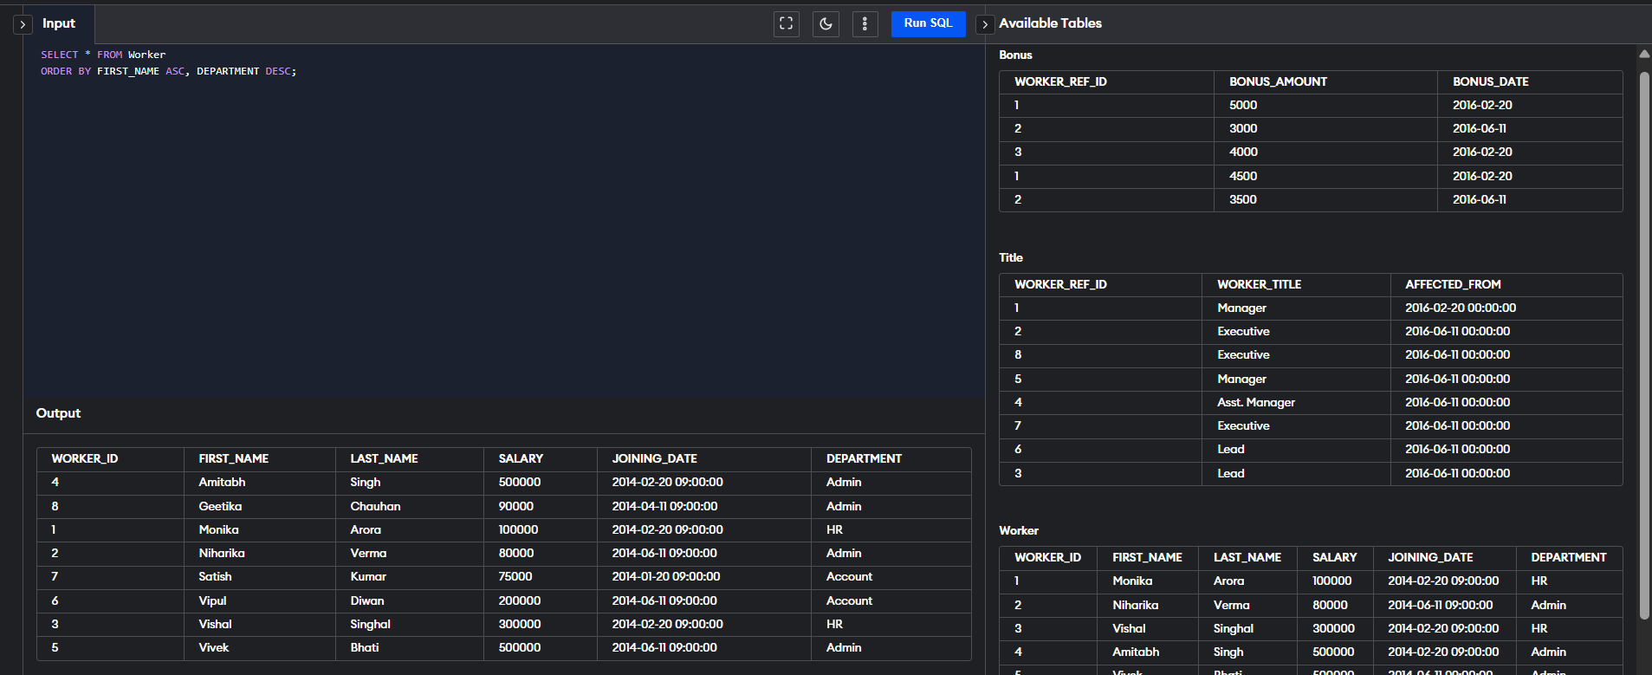

3. Write an SQL query to print details of the Workers whose FIRST_NAME contains ‘a’

**Answer:**

SELECT * FROM Worker

WHERE FIRST_NAME LIKE '%a%';

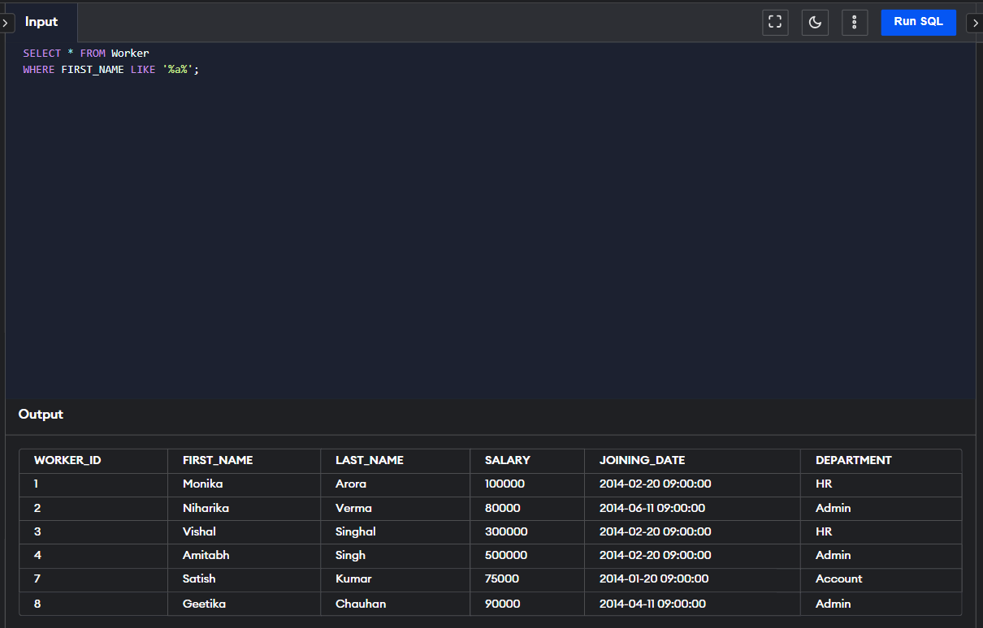

4. Write an SQL query to print details of the Workers whose FIRST_NAME ends with ‘h’ and contains six alphabets

Answer:

SELECT * FROM Worker

WHERE FIRST_NAME LIKE '_____h';

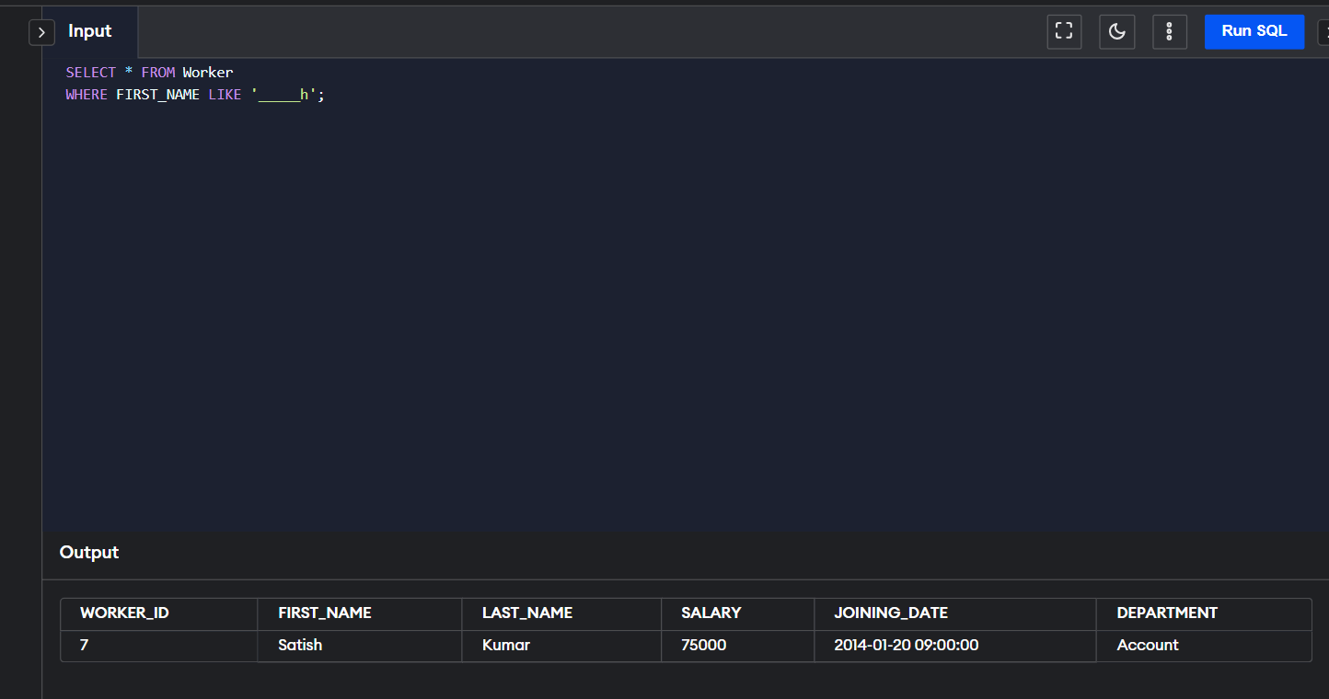

5. Write an SQL query to print details of the Workers whose SALARY lies between 100000 and 500000

Answer:

SELECT * FROM Worker

WHERE SALARY BETWEEN 100000 AND 500000;

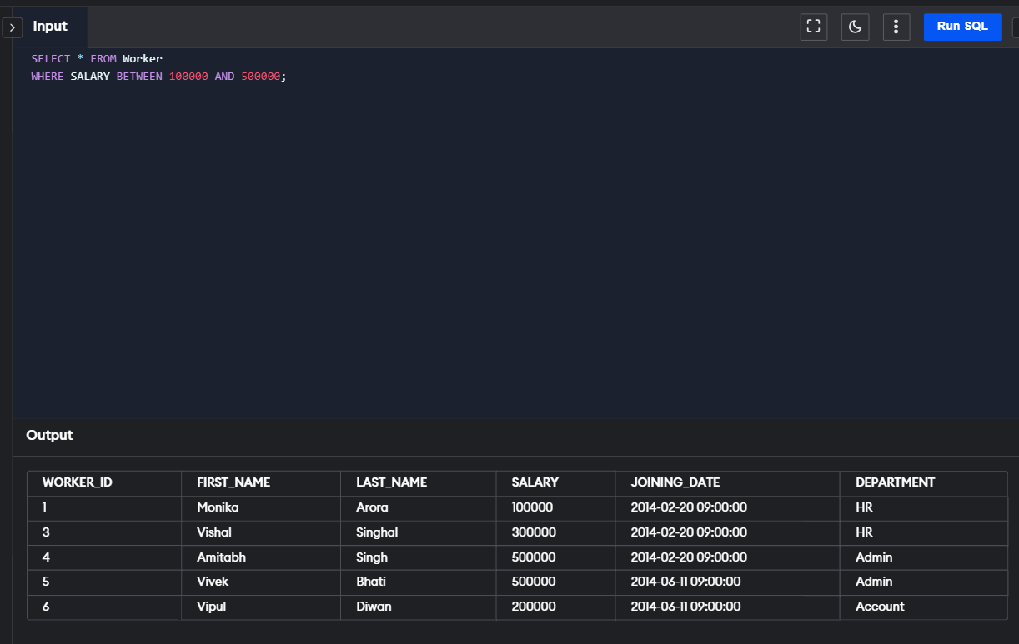

6. Write an SQL query to print details of the Workers who have joined in Feb’2014.

SELECT * FROM Worker

WHERE MONTH(JOINING_DATE) = 2 AND YEAR(JOINING_DATE) = 2014;

7. Write an SQL query to fetch the count of employees working in the department ‘Admin’

SELECT COUNT(*) AS AdminCount

FROM Worker

WHERE DEPARTMENT = 'Admin';



8. Write an SQL query to fetch worker names with salaries >= 50000 and <= 100000.

SELECT FIRST_NAME, LAST_NAME, SALARY

FROM Worker

WHERE SALARY BETWEEN 50000 AND 100000;

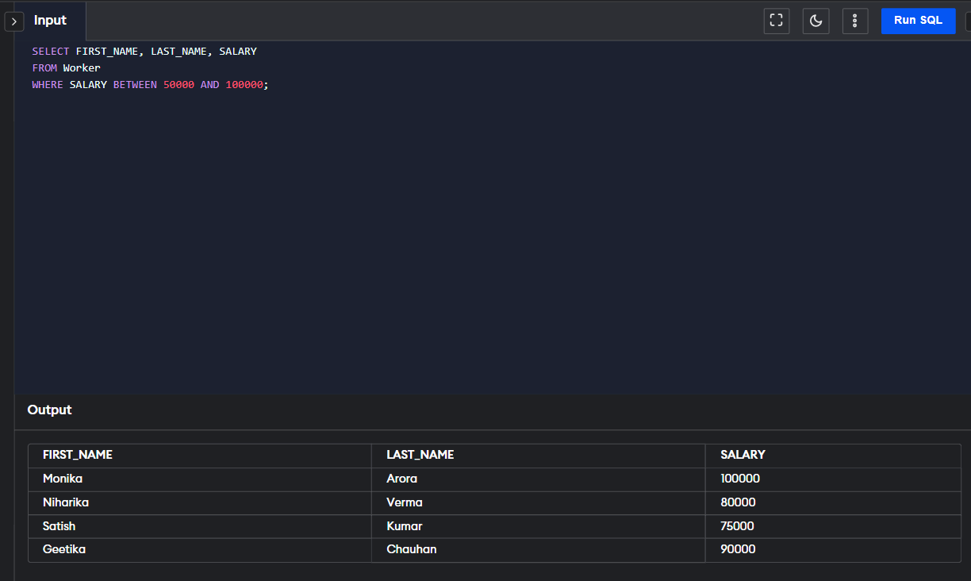

9. Write an SQL query to fetch the no. of workers for each department in the descending order

SELECT DEPARTMENT, COUNT(*) AS WorkerCount

FROM Worker

GROUP BY DEPARTMENT

ORDER BY WorkerCount DESC;



10. Write an SQL query to print details of the Workers who are also Managers

SELECT W.*

FROM Worker W

JOIN Title T ON W.WORKER_ID = T.WORKER_REF_ID

WHERE T.WORKER_TITLE = 'Manager';

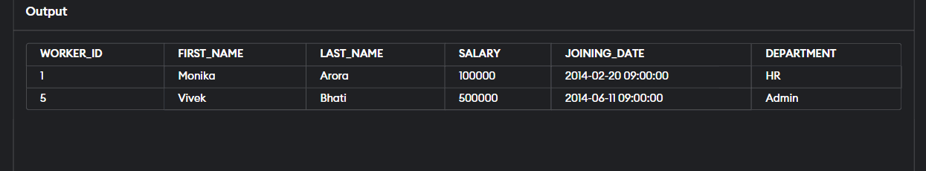

11. Write an SQL query to determine the 2nd lowest salary without using TOP or limit method.

SELECT MIN(SALARY) AS SecondLowestSalary

FROM Worker

WHERE SALARY > (

SELECT MIN(SALARY)

FROM Worker

);

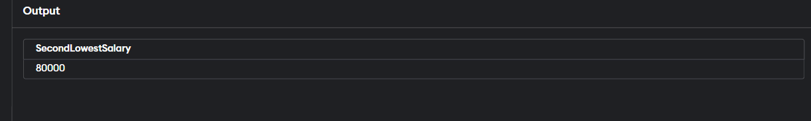

12. Write an SQL query to fetch the list of employees with the same salary

SELECT *

FROM Worker

WHERE SALARY IN (

SELECT SALARY

FROM Worker

GROUP BY SALARY

HAVING COUNT(*) > 1

);

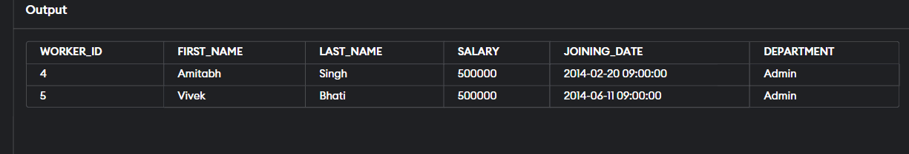

13. Write an SQL query to show the second highest salary from a table

SELECT MAX(SALARY) AS SecondHighestSalary

FROM Worker

WHERE SALARY < (SELECT MAX(SALARY) FROM Worker);



14. Write an SQL query to show one row twice in results from a table.

SELECT * FROM Worker WHERE WORKER_ID = 1

UNION ALL

SELECT * FROM Worker WHERE WORKER_ID = 1;

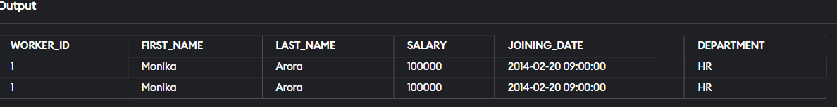

15. Write an SQL query to fetch the first 50% records from a table

WITH Ranked AS (

SELECT *,

ROW_NUMBER() OVER (ORDER BY WORKER_ID) AS rn,

COUNT(*) OVER () AS total_count

FROM Worker

)

SELECT *

FROM Ranked

WHERE rn <= total_count / 2;

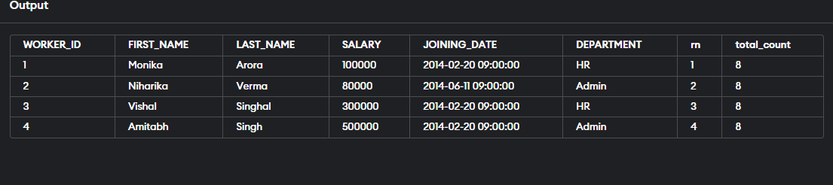

16. Write an SQL query to fetch the departments that have less than three people in it.

SELECT DEPARTMENT

FROM Worker

GROUP BY DEPARTMENT

HAVING COUNT(*) < 3;



17. Show all departments along with the number of people in each department

SELECT DEPARTMENT, COUNT(*) AS NumberOfPeople

FROM Worker

GROUP BY DEPARTMENT;



18. Write an SQL query to fetch the last five records from a table

SELECT *

FROM Worker

ORDER BY WORKER_ID DESC

LIMIT 5;

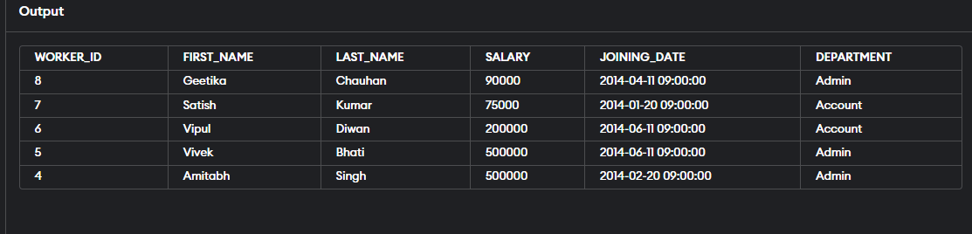

19. Write an SQL query to print the name of employees having the highest salary in each department

SELECT W.FIRST_NAME, W.LAST_NAME, W.SALARY, W.DEPARTMENT

FROM Worker W

WHERE W.SALARY = (

SELECT MAX(SALARY)

FROM Worker

WHERE DEPARTMENT = W.DEPARTMENT

)

ORDER BY W.DEPARTMENT;



20. Write an SQL query to fetch three max salaries from a table

SELECT DISTINCT SALARY

FROM Worker

ORDER BY SALARY DESC

LIMIT 3;



21. Write an SQL query to print the name of employees having the lowest salary in accunt and admin department

SELECT FIRST_NAME, LAST_NAME, SALARY, DEPARTMENT

FROM Worker

WHERE (DEPARTMENT = 'Account' OR DEPARTMENT = 'Admin')

AND SALARY = (

SELECT MIN(SALARY)

FROM Worker

WHERE DEPARTMENT = Worker.DEPARTMENT

AND (DEPARTMENT = 'Account' OR DEPARTMENT = 'Admin')

)

ORDER BY DEPARTMENT;

